APPLE STOCK PECNET BACTESTİNG WITH DIFFERENT PROPORTION OF TEST DATA

0.98 training:

Net Performance (%) 22.82840239999994
Number of Trades Executed = 34
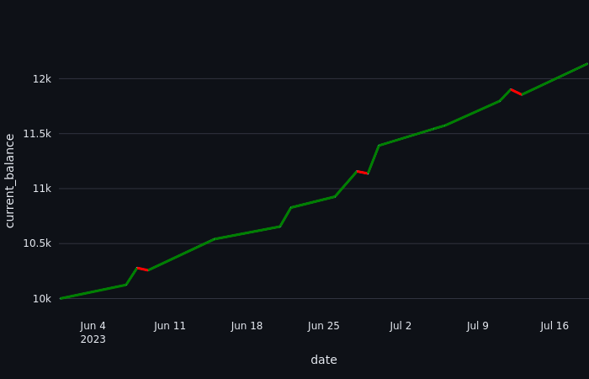
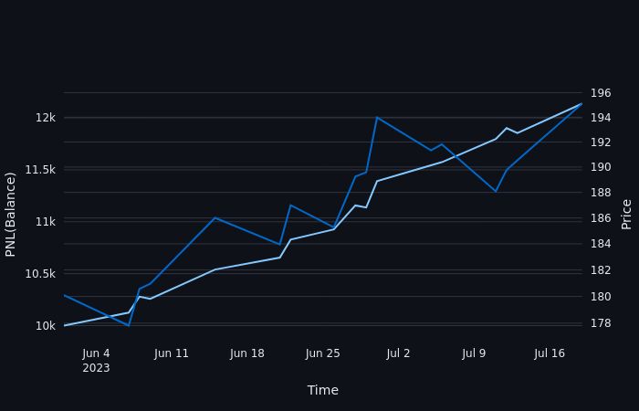

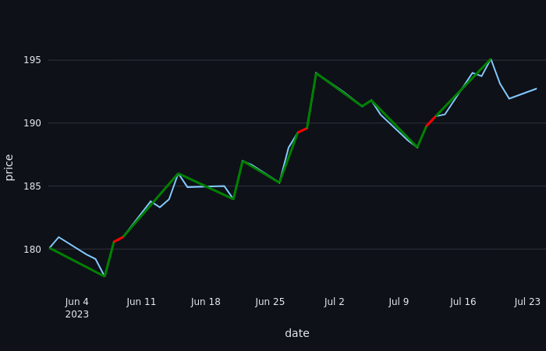

0.96 Training:

Net Performance (%) 62.55700399999987
Number of Trades Executed = 76
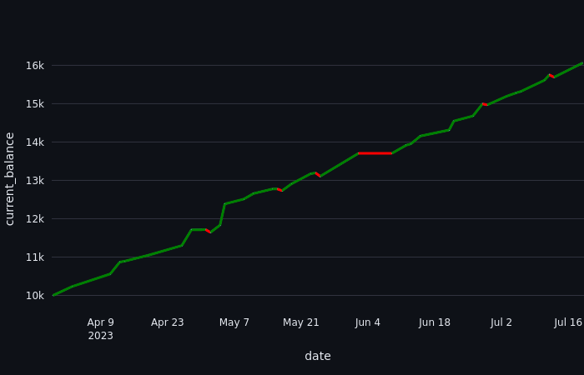
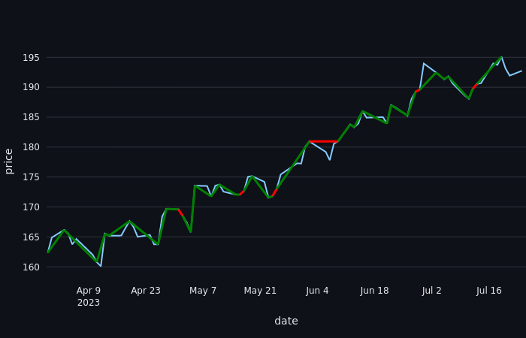

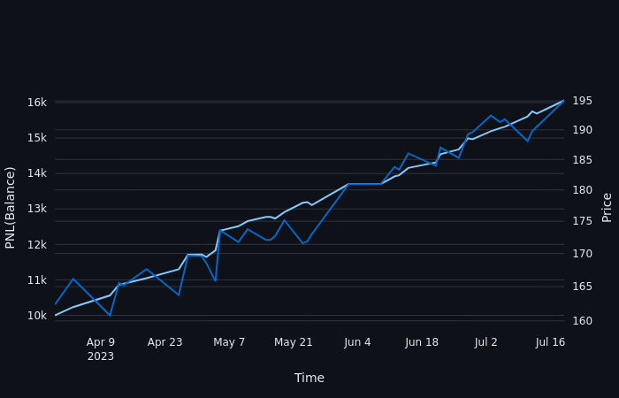

0.94 Training :
Net Performance (%) 140.90592149999983
Number of Trades Executed = 122

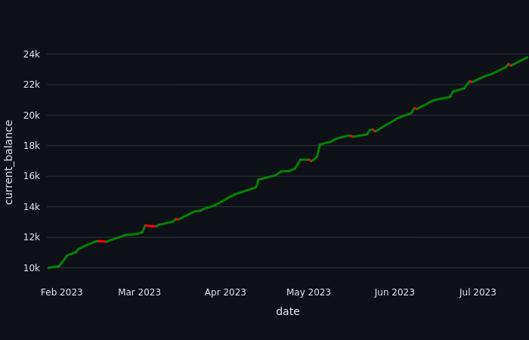
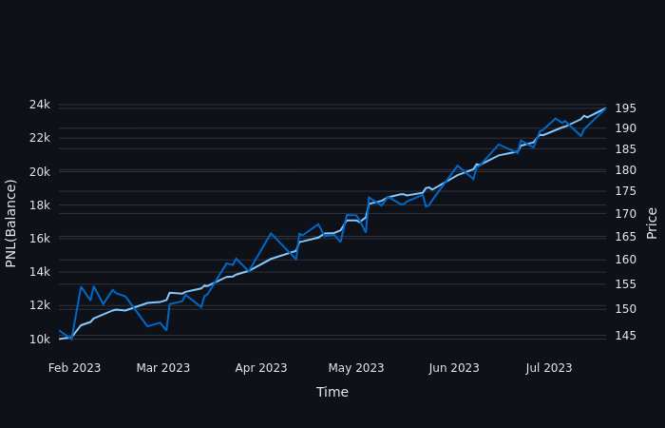
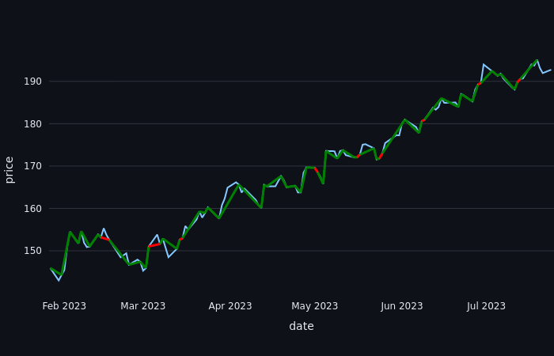

0.9 Training:
Net Performance (%) 543.5010229000002
Number of Trades Executed = 190
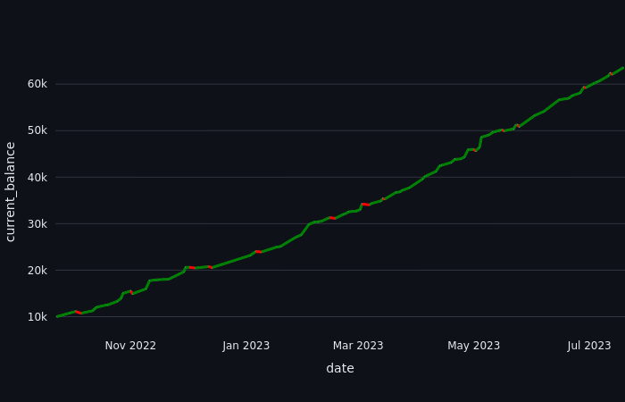

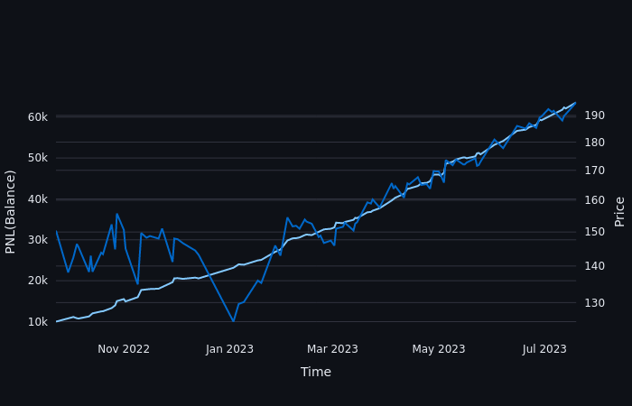
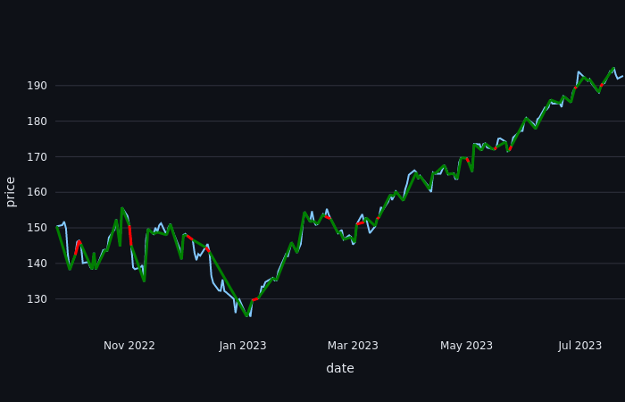

0.84 Training:
Net Performance (%) 1954.902325599998
Number of Trades Executed = 310
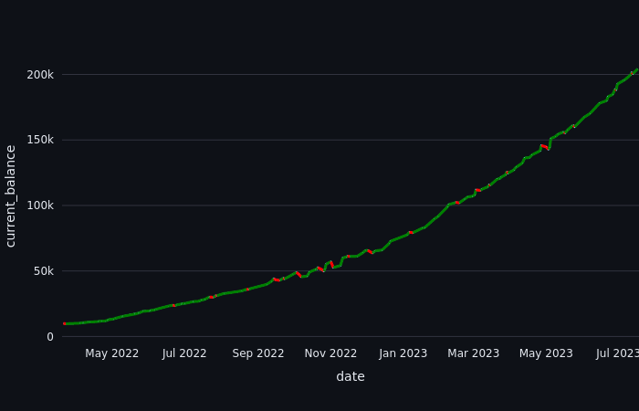
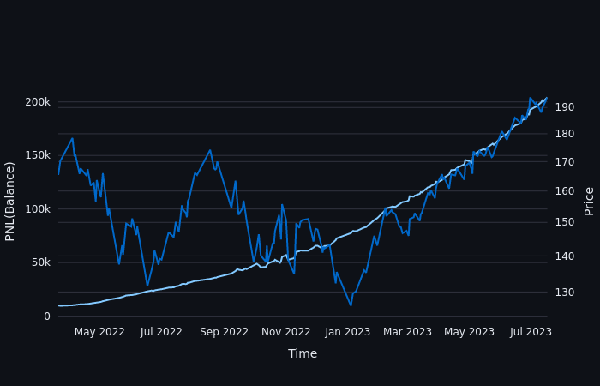

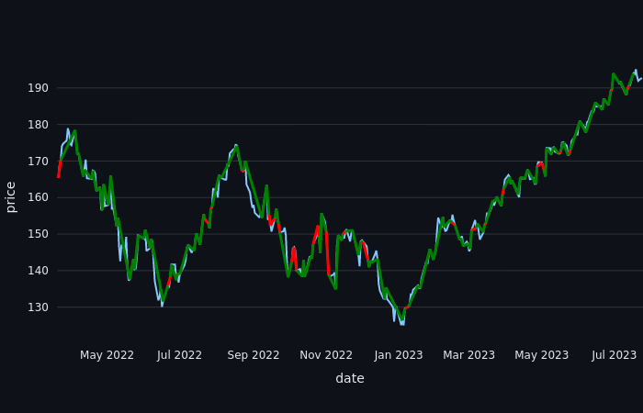

0.1 Training:
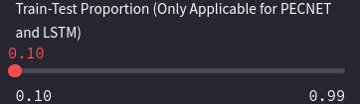

Net Performance (%) 38.593.949
Number of Trades Executed = 1448

